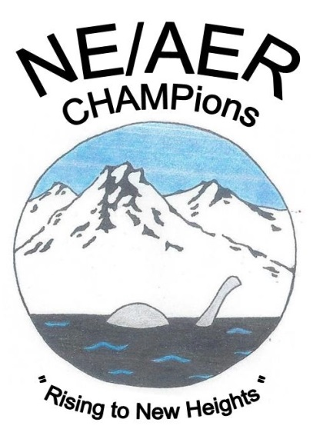

2017 NE/AER FALL CONFERENCE

Hilton Burlington

Burlington, Vermont

NOVEMBER 15-17, 2017

Exhibitor Date: November 16, 2017

August 15, 2017
Dear Valued Partner:

The Northeast chapter of the Association for the Education and Rehabilitation of the Blind and Visually Impaired invite you to participate in our vendor/exhibitor day at our upcoming conference in November in Burlington, Vermont. More than 200 professionals from throughout New England and the Maritime Provinces participate in this event every year. Learning from vendors about new products is always a highlight.

As usual, there will be an opportunity to place an ad in the participant program. See details below. The 6’ tables will have access to electricity, if requested, and wifi. Here are the things you need to know at a glance:

Where: The Hilton in Burlington, VT
When: November 16, 2017
Cost: Table/2 chairs/one lunch: $325 (postmarked by 9/1/17)
$350 (postmarked by 9/15/17)
$375 (postmarked by 9/30/17)
Ads: Full page: $150
½ page: $125
¼ page: $100

There are also a limited number of 30-minute vendor demonstration opportunities, so please let us know as soon as possible whether this is something that would interest you. These are offered on a first come, first served basis. And don’t forget the donor raffle! Registration confirmation and details will be sent in October. We look forward to hearing from you and to seeing you in Burlington on November 16th.

Sincerely,

Members of the Vendor Committee, 2017 NE-AER Conference

